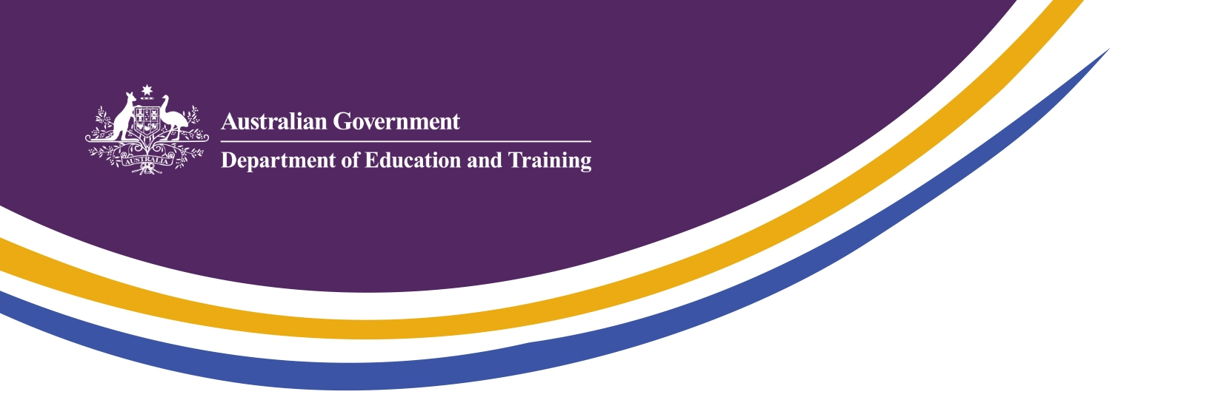
May 2015

Republic of Korea – Education & Research Partnership Opportunities

RoK Government Priorities
The Republic of Korea (RoK) Ministry of Education revised its key policies in 2014. The background to these changes included recognition of continuous changes in the global education environment, and can be viewed as a clear response to the government’s ambition to develop Korea as a “Creative Economy”. The policies emphasize the importance of the following aspects of education: development of character and creativity; responding to population and society changes; and developing capacity to address global issues like climate change. Public expectations of education were also recognised, with emphasis on the importance of: happy education and humanistic education; demand for structural reform of the university system; addressing a perceived mismatch between education and social demand; and demand for reduction of private education costs.
Key Strategies:
- Dreams and Talents: Happy school education, fostering students’ dreams and talents
- Creativity: High quality universities cultivating creative and talented people
- Challenge: Competency-based society where challengers can succeed
- Hope: Open opportunities for fulfilling people’s hope

Emerging trends
Korea’s drive for a “Creative Economy”: Government policy on innovation and education has focused on the vision for a “Creative Economy” as the next step in Korea’s economic development.
Internationalisation and restructuring of Korean Higher Education: Higher education policy in the RoK has been significantly focused on increasing the internationalisation of Korean institutions, with a particular emphasis on improving higher education quality and attracting international students in larger numbers.
Reassessment of the importance of competency based skills: The ROK continues to examine the role and design of the technical vocational education and training (TVET) sector. The RoK Government has pursued an active dialogue with Australia on its vocational education and training and skills system and will utilise aspects of the Australian model for integration in its current redesign of the Korean skills system.

Opportunities for Australia
Australia and Korea can encourage and grow sustainable partnerships between our institutions as the basis for expansion in collaborative research. The complementary research strengths of Australia (in basic science) and the RoK (in applied science and commercialisation of research) provide opportunities for mutual benefit in expanding our research links.
Building on the suite of supported mobility activities including the Endeavour Scholarship and Fellowship program and the New Colombo Plan, Australian higher education providers can encourage students to consider the RoK as a mobility destination. Korean universities offer an expanding range of courses in English, and provide summer and winter short-courses which accommodate the Australian academic year. Strong university-industry linkages in Korea can also provide valuable internship opportunities for Australian students.

Our key goals

Deepen engagement between all Australian and Korean education sectors

Promote mobility at institutional, researcher and student level

Increased research collaboration

Collaborate in multilateral regional education fora

Forward schedule of key activities and events
Australia-Korea Research Roundtable: May 2015 - This event will bring together researchers from Korean universities and research organisations with research linkages to Australian institutions to identify current links and opportunities for further engagement.
Future Unlimited Education Exhibition – Seoul and Busan, October 2015 – Austrade all-sector education exhibition, to be augmented in 2015 with Department of Education and Training ancillary events to bring together Korean partner institutions, government representatives and alumni.
10th Global HR Forum – Seoul, 3-4 November 2015 – The Global HR Forum is a high profile annual conference (5,000+ attendees) convened in Seoul by RoK Ministry of Education, the Korea Economic Daily newspaper and the Korea Research Institute for Vocational Education and Training (KRIVET). The theme for 2015 is “Global Talent, Global Prosperity”.
Australia-Korea 4th Joint Committee on Education – Seoul, early 2016 – Fourth round of regular bilateral discussions between Australia and the RoK on education and research.

